Ideation Phase
Empathize & Discover

Date | 08 July 2026
Team ID
Project Name | Sports Hall Booking System
Maximum Marks | 4 Marks

Empathy Map Canvas:
For the Sports Hall Booking System, the empathy map focuses on students and sports facility users who require a simple, reliable, and efficient method to reserve sports halls. By analyzing what users think, feel, see, say, do, hear, and experience, the system was designed to provide a user-friendly online booking platform through the ServiceNow Service Portal. This approach ensures improved convenience, minimizes booking conflicts, enhances transparency, and delivers a better overall booking experience..

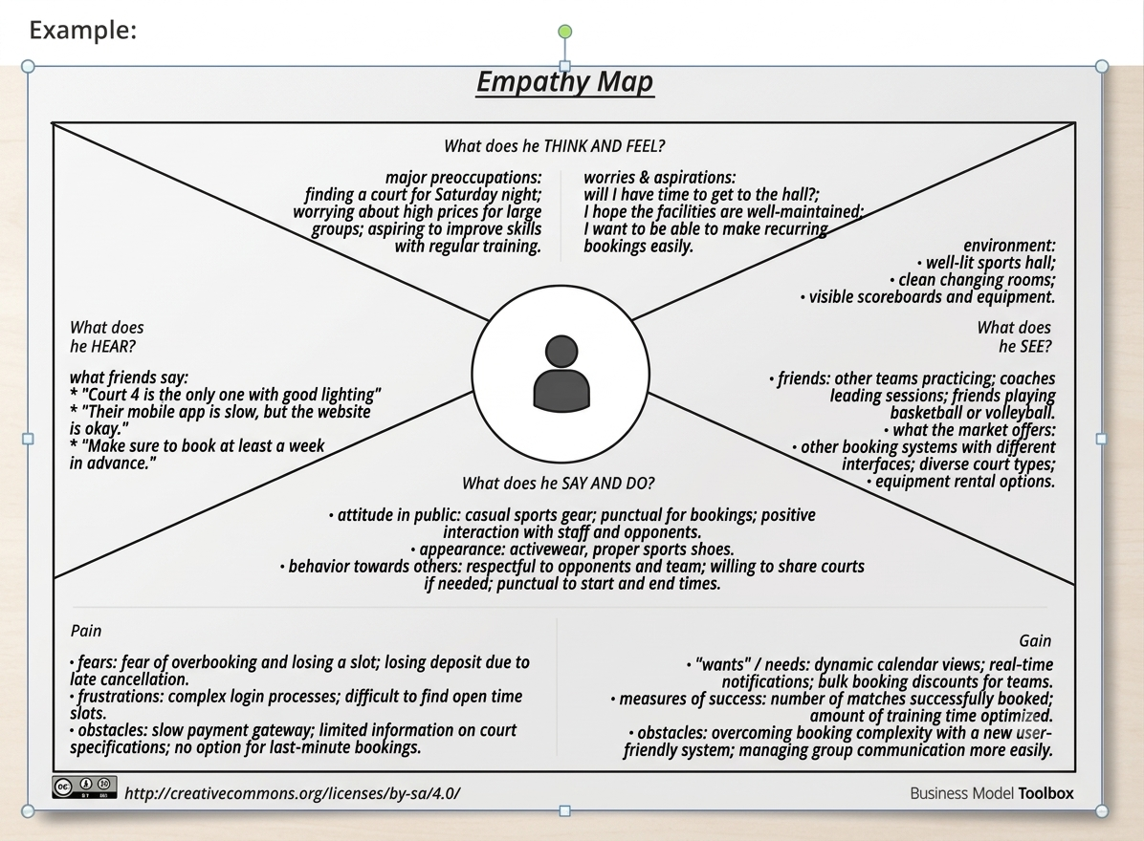

User Persona
Primary User: Student / Sports Club Member who wants to reserve a sports hall.

Empathy Map Canvas For Sports Hall Booking System

